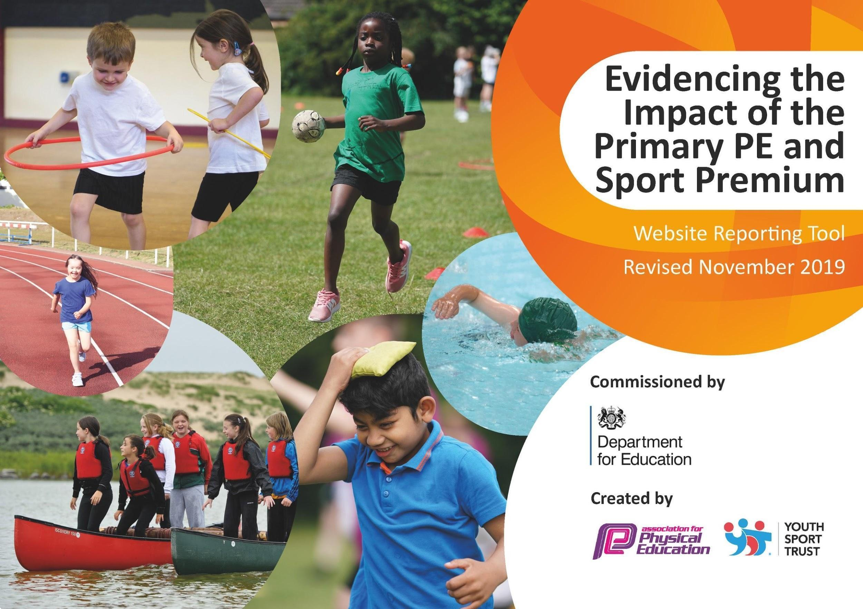
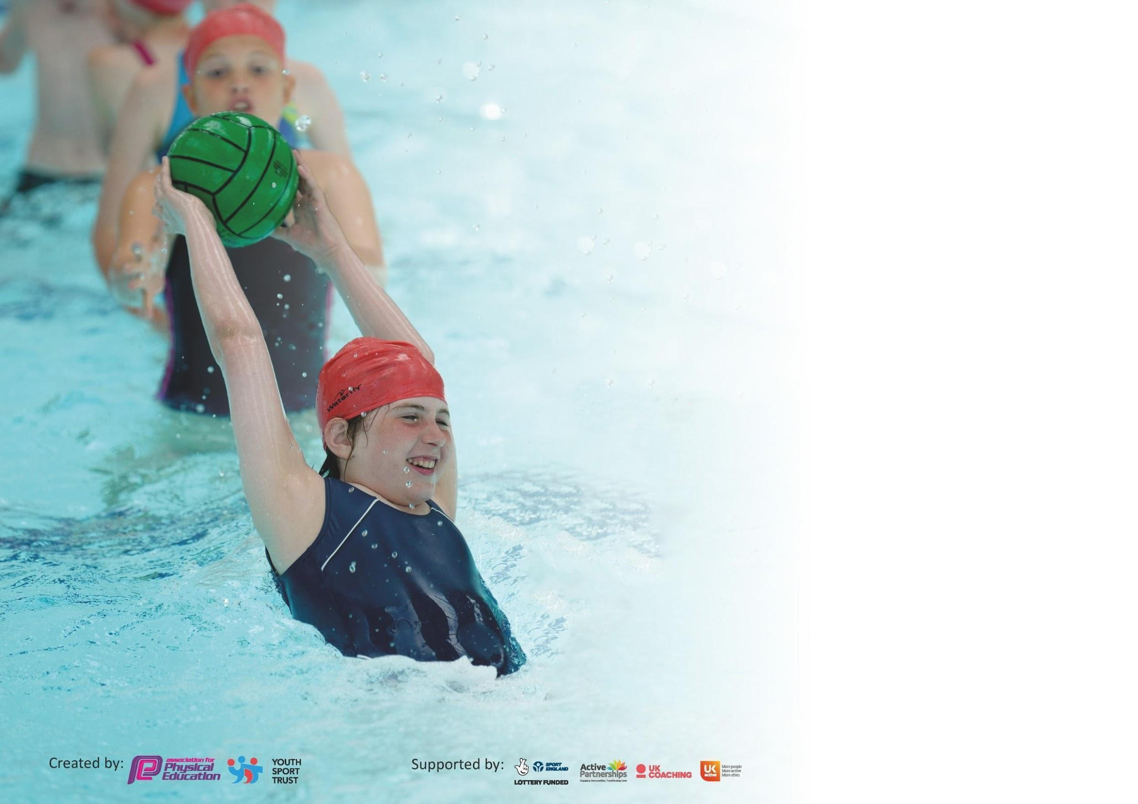

It is important that your grant is used effectively and based on school need. The Education Inspection Framework (Ofsted 2019 p64) makes clear there will be a focus on ‘whether leaders and those responsible for governors all understand their respective roles and perform these in a way that enhances the effectiveness of the school’.

Under the Quality of Education criteria (p41) inspectors consider the extent to which schools can articulate their curriculum (INTENT), construct their curriculum (IMPLEMENTATION) and demonstrate the outcomes which result (IMPACT).

To assist schools with common transferable language this template has been developed to utilise the same three headings which should make your plans easily transferable between working documents.

Schools must use the funding to make additional and sustainable improvements to the quality of Physical Education, School Sport and Physical Activity (PESSPA) they offer. This means that you should
use the Primary PE and Sport Premium to:

- Develop or add to the PESSPA activities that your school already offer
- Build capacity and capability within the school to ensure that improvements made now will benefit pupils joining the school in future years

Please visit gov.uk for the revised DfE guidance including the 5 key indicators across which schools should demonstrate an improvement. This document will help you to review your provision and to report your spend. DfE encourages schools to use this template as an effective way of meeting the reporting requirements of the Primary PE and Sport Premium.

We recommend you start by reflecting on the impact of current provision and reviewing the previous spend.

Schools are required to publish details of how they spend this funding as well as on the impact it has on pupils’ PE and sport participation and attainment by the end of the summer term or by 31st July 2020 at the latest.

We recommend regularly updating the table and publishing it on your website throughout the year. This evidences your ongoing self-evaluation of how you are using the funding to secure maximum, sustainable impact. Final copy must be posted on your website by the end of the academic year and no later than the 31st July 2020. To see an example of how to complete the table please click HERE.
ENCLOSURE J

Support for review and reflection - considering the 5 key indicators from DfE, what development needs are a priority for your setting and your pupils now and why? Use the space below to reflect on previous spend and key achievements and areas for development.

Key achievements to date until July 2021: | Areas for further improvement and baseline evidence of need:
- Sports Coach and specialists continued to provide high quality PE to pupils throughout COVID, including providing remote PE lessons during school closure period  - Achieved the School’s Gamesmark Award.  - Sports Coaches and specialists have worked alongside other teaching staff to deliver high quality PE to pupils and provide guidance to teachers to ensure a sustained impact.  - Athletics, football and cricket teams compete in inter school competitions allowing more children to gain confidence in their sporting achievement and become accustomed to the challenge of competition.  -Subscribed to the Getset4PE planning scheme which will enable teachers to be more confident in teaching a range of sports over a series of lessons. Children should receive a more thorough and rounded physical education. | - Reestablish clubs and participation in competitions  - Ensure P.E. curriculum map is adhered to - Getset4PE plans followed throughout all year groups and feedback reported to PE coordinator via the use of mini-PE-leads  - Focus on the impact of PE on mental health  - Introduce learning conversations as a tool for assessment within PE.  - Continue to invest in sports resources

Meeting national curriculum requirements for swimming and water safety. | Where can we get this data?
What percentage of your current Year 6 cohort swim competently, confidently and proficiently over a distance of at least 25 metres?  N.B. Even though your pupils may swim in another year please report on their attainment on leaving  primary school at the end of the summer term 2020. | 30%
What percentage of your current Year 6 cohort use a range of strokes effectively [for example, front crawl, backstroke and breaststroke]? | 20%
What percentage of your current Year 6 cohort perform safe self-rescue in different water-based situations? | 20%
Schools can choose to use the Primary PE and Sport Premium to provide additional provision for swimming but this must be for activity over and above the national curriculum requirements. Have you used it in this way? | No

Action Plan and Budget Tracking
Capture your intended annual spend against the 5 key indicators. Clarify the success criteria and evidence of impact that you intend to measure to evaluate for pupils today and for the future.

Academic Year: 2021/22 | Total fund allocated: Forecasted amount £23190 | Date Updated:
Key indicator 1: The engagement of all pupils in regular physical activity – Chief Medical Officer guidelines recommend that primary school pupils undertake at least 30 minutes of physical activity a day in school |  |  |  | Percentage of total allocation:
 |  |  |  | 26 %
Intent | Implementation |  | Impact
Your school focus should be clear what you want the pupils to know and be able to do and about  what they need to learn and to  consolidate through practice: | Make sure your actions to achieve are linked to your intentions: | Funding allocated: | Evidence of impact: what do pupils now know and what can they now do? What has changed?: | Sustainability and suggested next steps:
To ensure all children have the opportunity to remain active and engage closely with PE.  - Maintenance of play equipment to ensure there are opportunities for active breakfast club, play times and lunch times.  - Delivery of extra-curricular clubs  - Maintenance of PE equipment | - Make resources available to all staff to facilitate active breakfast club, play times and lunch times. (football, basketball, skipping, pogo sticks, hoppers)  - TAs to deliver activities before school  - Extra-curricular clubs to be delivered by teaching staff  - Ensure lessons are sufficiently resourced  - PE Coordinator to oversee PE delivery within the school | £2873 (PE Coodinator TLR)  £4400 (Maintenance of equipment and delivery of clubs) | - Resources available in the playground  - Children trying “new” sports  - Full pupil participation including those with special educational needs | Continued investment in PE equipment, particularly PE equipment that can be used by pupils during playtimes.  Re-establishment of extra-curricular clubs and intra-school tournaments both before, during and after the normal school hours.  A rota system in place to encourage children to participate in different sports.  Next Step: Continue to grow our extra-curricular club and competition offering.
Key indicator 2: The profile of PESSPA being raised across the school as a tool for whole school improvement |  |  |  | Percentage of total allocation:
 |  |  |  | 4%
Intent | Implementation |  | Impact
Your school focus should be clear what you want the pupils to know and be able to do and about  what they need to learn and to  consolidate through practice: | Make sure your actions to achieve are linked to your intentions: | Funding allocated: | Evidence of impact: what do pupils now know and what can they now do? What has changed?: | Sustainability and suggested next steps:
To develop and refine pupil’s sports skills whilst raising the profile of sport and activities within the school.  - Educate children about living a physical and healthy lifestyle  - Continue to raise the profile of sport in school  - Ensure all sporting achievements are recognised | - Reestablish residential for Y6 pupils to attend - promoting physical activity and good health  - Sporting achievements celebrated in assemblies and school newsletters  - Promote the impact of PE on mental wellbeing | £1,000 allocated (day trips at end of academic year rather than residential due to Covid restrictions) | - Children developing key skills  - Children developing a love for competitive sport  - Teachers delivering high quality PE lessons  - Children develop mental and physical resilience | The residential trip was reestablished.  There were many opportunities for both intra and inter school competition offered to children.  All year groups were exposed to a variety of sports taught across a series of lessons in PE.  School awarded Platinum Gamesmark.  Next Step: Focus on children’s core fitness including the possibility of introducing the daily mile.

Key indicator 3: Increased confidence, knowledge and skills of all staff in teaching PE and sport |  |  |  | Percentage of total allocation:
 |  |  |  | 60%
Intent | Implementation |  | Impact
Your school focus should be clear | Make sure your actions to | Funding | Evidence of impact: what do | Sustainability and suggested
what you want the pupils to know | achieve are linked to your | allocated: | pupils now know and what | next steps:
and be able to do and about | intentions: |  | can they now do? What has
what they need to learn and to |  |  | changed?:
consolidate through practice:
Teachers to deliver high quality PE Lessons through access to a full time sports coach and the Getset4pe scheme.  - Continue to provide a wide variety of sports and activities for children to access in PE lessons through the Getset4PE programme.  - Provide teachers access to the online resources and platform for Getset4PE  - Sports coach CPD  - Sports coach to team teach alongside class teachers delivering PE, providing CPD and upskilling  - Children to benefit from teacher’s improved subject knowledge and confidence in PE delivery | - Pay annual subscription to Getset4PE  - Sports coach timetabled to work alongside class teachers  - Plan learning conversations for teachers to reflect on planning and delivery of Getset4PE lessons  - PE coordinator to work alongside PE coach to ensure adherence to Getset4PE plans | GetSet4PE - £1375  Sports coach salary - £15,000 | Children’s skills are improving across all sports. All year groups are using the same resource so consistency should lead to a cumulative improvement.  - PE planning and assessment  - Class and PE coordinator timetables | The Getset4PE curriculum has been taught for a full academic year for the first time.  Next Step: Continue to roll out learning conversations in order for further assessment of the impact of the scheme.  Consider bringing in more expertise to support the teaching of gymnastics.
Key indicator 4: Broader experience of a range of sports and activities offered to all pupils |  |  |  | Percentage of total allocation:
 |  |  |  | 1%
Intent | Implementation |  | Impact
Your school focus should be clear | Make sure your actions to | Funding | Evidence of impact: what do | Sustainability and suggested
what you want the pupils to know | achieve are linked to your | allocated: | pupils now know and what | next steps:
and be able to do and about | intentions: |  | can they now do? What has
what they need to learn and to |  |  | changed?:
consolidate through practice:
Provide children with access to a wide-ranging, variety of sports.  - Delivery of high quality PE lessons and sports clubs  - Provide additional sports provision before and after school as well as to more vulnerable groups including SEN pupils (Handball, dance, football, cricket after school clubs as well as before school athletics club)  - Enthuse children about sport | - Reestablish clubs after COVID restrictions - before and after school clubs, Saturday club for vulnerable pupils. PE coordinator and PE coach to target Pupil Premium, SEN pupils and other vulnerable pupils to attend clubs  - PE professional coach, dance teacher and cricket coach to teach both during PE and extra-curricular sports clubs  - Subsidised trips  - Use of medals and trophies to motivate and excite children to enter into competitive sport | Sports coach salary (see above)  £350 for medals and trophies | - Pupil’s achieving their personal best  - Excitement and interest amongst pupil’s relating to sport and PE  - High attendance across all sports clubs  - Healthy, fit pupils  - Equal access to PE amongst different groups of pupils | Successful delivery of sports days  Additional sports provision provided before, during and after school.  Additional PE lessons provided during the holidays, including Easter holidays and Summer holidays for children attending booster and HAF provision. Sports club provided for the weekends.  PE lessons designed and implemented specifically for SEN children.  Y3/4 girls football team winning a competition. Following this, the headteacher delivered an assembly about women in sport in order to create excitement and enthuse children (particularly girls about sport).  Next Step: Continue to boost the profile of sport through special assemblies, events and competitions.

Key indicator 5: Increased participation in competitive sport |  |  |  | Percentage of total allocation:
 |  |  |  | 9%
Intent | Implementation |  | Impact
Your school focus should be clear | Make sure your actions to | Funding | Evidence of impact: what do | Sustainability and suggested
what you want the pupils to know | achieve are linked to your | allocated: | pupils now know and what | next steps:
and be able to do and about | intentions: |  | can they now do? What has
what they need to learn and to |  |  | changed?:
consolidate through practice:
Continue to provide opportunities for children to participate in competitive sports.  - Partnering with Langdon Academy  - Increase the opportunities for physical activity throughout the school day | - Children to participate in sporting competitions across both key stages  - Maximise on staff training opportunities  - Opportunities to network with other schools and develop links with other agencies  - Support with organisation and running of school sports days. | £2500 for Langdon | - Children developing key skills  - Children developing a love for competitive sport  - Teachers delivering high quality PE lessons | Langdon partnership provided team teaching for NQTs and sports day organisation.

Signed off by
Head Teacher: | Sukwinder Samra
Date: | 25 September 2021
Subject Leader: | Andrew Sheppard
Date: | 25 September 2021
Governor: | Marjorie Browne
Date: | 6th July 2022

