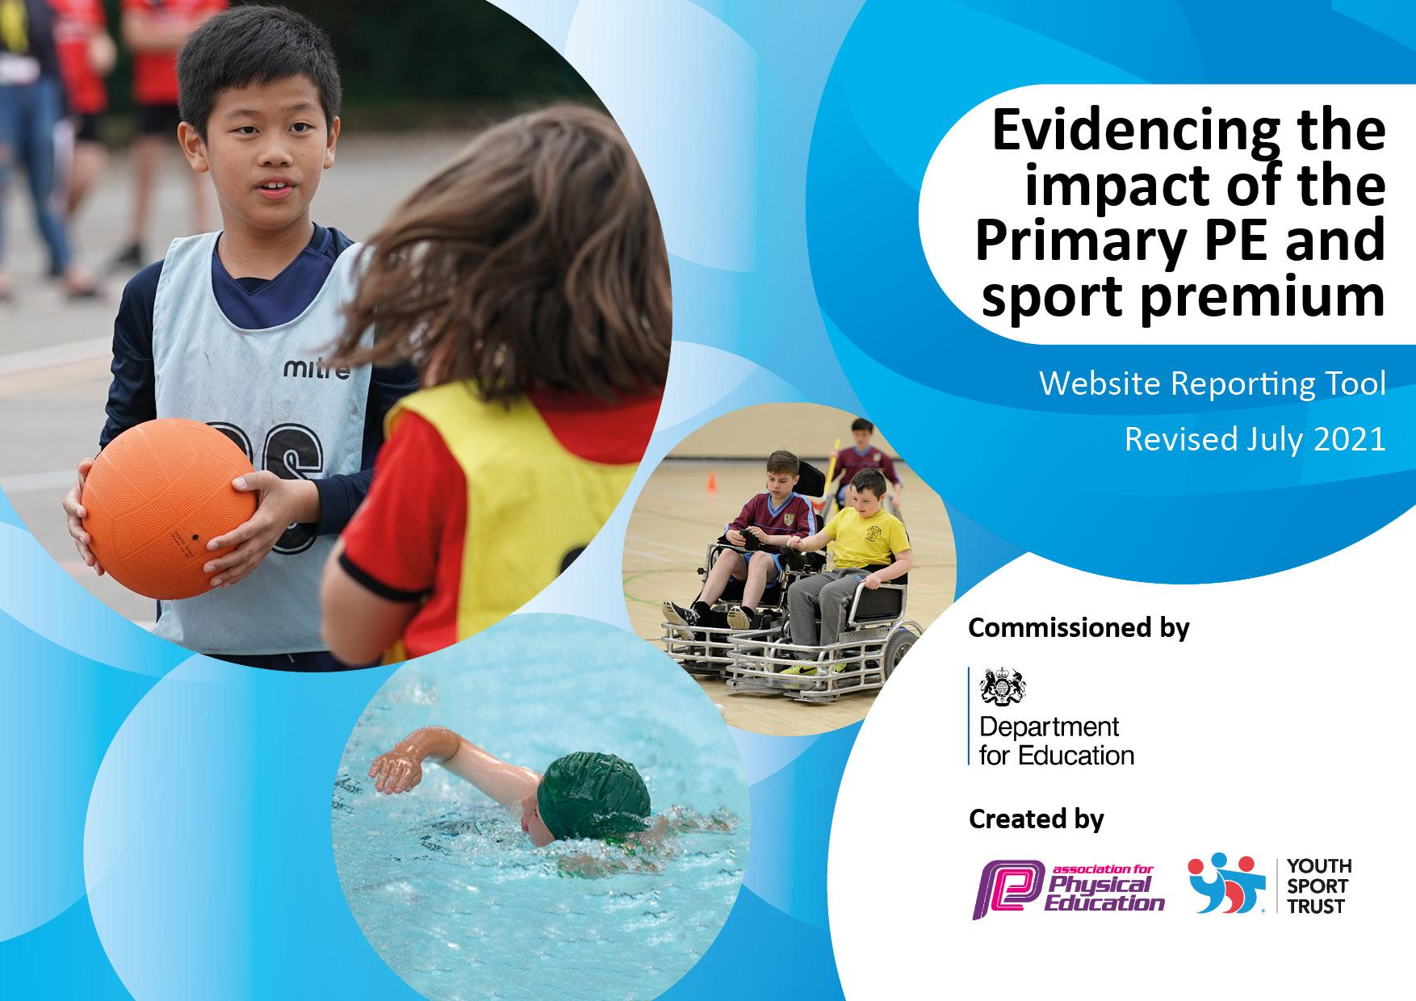
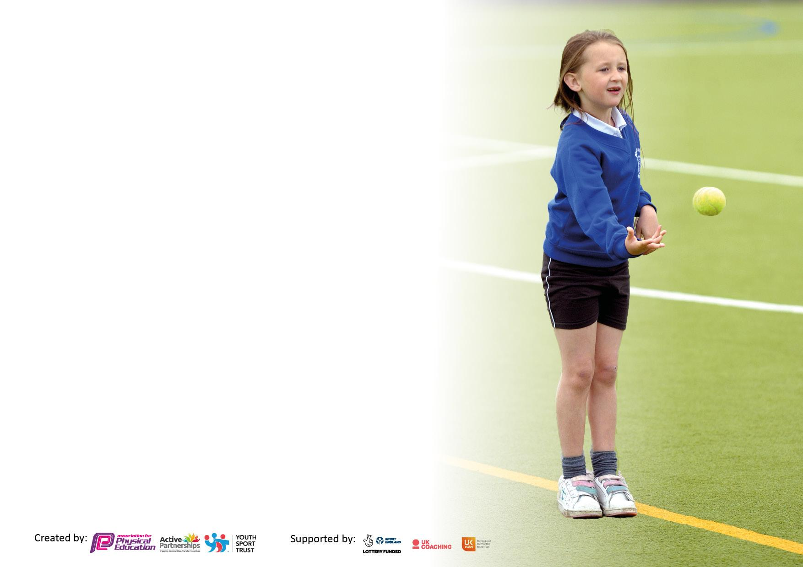

It is important that your grant is used effectively and based on school need. The Education Inspection Framework makes clear there will be a focus on ‘whether leaders and those responsible for governors all understand their respective roles and perform these in a way that enhances the effectiveness of the school’.

Under the Quality of Education Ofsted inspectors consider:
Intent - Curriculum design, coverage and appropriateness
Implementation - Curriculum delivery, Teaching (pedagogy) and Assessment
Impact - Attainment and progress

To assist schools with common transferable language this template has been developed to utilise the same three headings which should make your plans easily transferable between working documents.

Schools must use the funding to make additional and sustainable improvements to the quality of Physical Education, School Sport and Physical Activity (PESSPA) they offer. This means that you should use the Primary PE and sport premium to:

- Develop or add to the PESSPA activities that your school already offer
- Build capacity and capability within the school to ensure that improvements made now will benefit pupils joining the school in future years
- The Primary PE and sport premium should not be used to fund capital spend projects; the school’s budget should fund these.

Pleasevisitgov.ukfortherevisedDfEguidanceincludingthe5keyindicatorsacrosswhichschoolsshoulddemonstrate animprovement.Thisdocumentwillhelpyoutoreviewyourprovisionandtoreportyourspend.DfEencouragesschools to use this template as an effective way of meeting the reporting requirements of the Primary PE and sport premium.

We recommend you start by reflecting on the impact of current provision and reviewing the previous spend.

Schools are required to publish details of how they spend this funding, including any under-spend from 2019/2020, as well as on the impact it has on pupils’ PE and sport participation and attainment. All funding must be spent by 31st July 2022.

We recommend regularly updating the table and publishing it on your website throughout the year. This evidences your ongoing self-evaluation of how you are using the funding to secure maximum, sustainable impact. Final copy must be posted on your website by the end of the academic year and no later than the 31st July 2021. To see an example of how to complete the table please click HERE.

Details with regard to funding
Please complete the table below.

Total amount carried over from 2020/21 | £0
Total amount allocated for 2021/22 | £23190
How much (if any) do you intend to carry over from this total fund into 2022/23 | £0
Total amount allocated for 2022/23 | £ 23140
Total amount of funding for 2022/23 To be spent and reported on by 31st July 2023. | £ 23140

Swimming Data
Please report on your Swimming Data below.

Meeting national curriculum requirements for swimming and water safety.

N.B. Complete this section to your best ability. For example you might have practised safe self-rescue techniques on dry land which you can then transfer to the pool when school swimming restarts.
Due to exceptional circumstances priority should be given to ensuring that pupils can perform safe self rescue even if they do not fully meet the first two requirements of the NC programme of study
What percentage of your current Year 6 cohort swim competently, confidently and proficiently over a distance of at least 25 metres?  N.B. Even though your pupils may swim in another year please report on their attainment on leaving primary school at the end of the summer term 2020.  Please see note above | 33%
What percentage of your current Year 6 cohort use a range of strokes effectively [for example, front crawl, backstroke and breaststroke]?  Please see note above | 25%
What percentage of your current Year 6 cohort perform safe self-rescue in different water-based situations? | 25%
Schools can choose to use the Primary PE and sport premium to provide additional provision for swimming but this must be for activity over and above the national curriculum requirements. Have you used it in this way? | No

Action Plan and Budget Tracking
Capture your intended annual spend against the 5 key indicators. Clarify the success criteria and evidence of impact that you intend to measure to evaluate for pupils today and for the future.

Academic Year: 2021/22 | Total fund allocated: £23140 | Date Updated:
Key indicator 1: The engagement of all pupils in regular physical activity – Chief Medical Officers guidelines recommend that primary school pupils undertake at least 30 minutes of physical activity a day in school |  |  |  | Percentage of total allocation:
 |  |  |  | %
Intent | Implementation |  | Impact
Your school focus should be clear what you want the pupils to know and be able to do and about  what they need to learn and to  consolidate through practice: | Make sure your actions to achieve are linked to your intentions: | Funding allocated: | Evidence of impact: what do pupils now know and what can they now do? What has changed?: | Sustainability and suggested next steps:
To ensure all children have the opportunity to remain active and engage closely with PE.  - Maintaining and updating play equipment to ensure there are opportunities for active breakfast club, play times and lunch times  - Delivery of extra-curricular clubs  - Maintenance of PE equipment | - Make resources available to all staff to facilitate active breakfast club, play times and lunch times (basketballs and hoops, footballs and nets, handballs and nets, cricket equipment, skipping ropes, table tennis bats and balls)  - TAs to deliver activities before school  - Extra- curricular clubs to be delivered by teaching staff  - Ensure lessons are sufficiently resourced  - PE coordinator to oversee delivery of PE within the school | £2873 - (PE coordinator TLR)  £4400 - (Maintenance of PE Equipment and delivery of clubs) | - Resources available in the playground  - Children trying “new” sports  - Full pupil participation  - This has certainly positively impacted the girls who have seen sporting success in football and cricket competitions
Key indicator 2: The profile of PESSPA being raised across the school as a tool for whole school improvement |  |  |  | Percentage of total allocation:
 |  |  |  | %
Intent | Implementation |  | Impact
Your school focus should be clear what you want the pupils to know and be able to do and about  what they need to learn and to  consolidate through practice: | Make sure your actions to achieve are linked to your intentions: | Funding allocated: | Evidence of impact: what do pupils now know and what can they now do? What has changed?: | Sustainability and suggested next steps:
To develop and refine pupils’ sports skills whilst raising the profile of sport and activities within the school:  - Educate children about living a physical and healthy lifestyle  - Continue to raise the profile of sport within school  - Ensure all sporting achievements are recognised | - Continue the residential for Y6 pupils to attending - promoting physical activity and good health  - Sporting achievements recognised and celebrated in assemblies and the school newsletter  - Special assemblies and lessons relating to special events such as the Commonwealth Games or Women in sport  - Promote the impact of PE on mental wellbeing  - Add time within PE lessons to focus on physical fitness | £1500 - Cost of Y6 residential | - Children developing key skills  - Children developing a love for competitive sport  - Children developing a sense of achievement from success  - Teachers delivering high quality PE lessons  - Children develop physical and mental resilience  - Children developing an understanding of what is necessary to remain fit and healthy

Key indicator 3: Increased confidence, knowledge and skills of all staff in teaching PE and sport |  |  |  | Percentage of total allocation:
 |  |  |  | %
Intent | Implementation |  | Impact
Your school focus should be clear | Make sure your actions to | Funding | Evidence of impact: what do | Sustainability and suggested
what you want the pupils to know | achieve are linked to your | allocated: | pupils now know and what | next steps:
and be able to do and about | intentions: |  | can they now do? What has
what they need to learn and to |  |  | changed?:
consolidate through practice:
Teachers to deliver high quality PE lessons through access to a full time sports coach and the Getset4PE scheme.  - Continue to provide a wide variety of sports and activities for children to access in PE lessons through the Getset4pe programme.  - Provide teachers access to the online resources and platform for Getset4PE  - Sports coach CPD  - Sports coach to teach teach alongside class teachers deliver PE, providing CPD and upskilling  - Children to benefit from teachers improved subject knowledge and confidence in PE delivery | - Pay an annual subscription to Getset4PE  - Sportscoach timetabled to work alongside class teachers  - Plan learning conversations for teachers to reflect on planning and delivery of Getset4PE lessons  - PE coordinator to work alongside the PE coach to ensure adherence to Getset4PEplans  - PE coordinator to collaborate with PE coordinators within the MAT to share ideas and good practice | £1375 - Getset4PE  £15000 - Sports Coach Salary | Children’s skills are improving across all sports. All year groups are using the same resources so consistency should lead to a cumulative improvement.  - PE planning and assessment  - Class and PE coordinator timetables
Key indicator 4: Broader experience of a range of sports and activities offered to all pupils |  |  |  | Percentage of total allocation:
Intent | Implementation |  | Impact
Your school focus should be clear | Make sure your actions to | Funding | Evidence of impact: what do | Sustainability and suggested
what you want the pupils to know | achieve are linked to your | allocated: | pupils now know and what | next steps:
and be able to do and about | intentions: |  | can they now do? What has
what they need to learn and to |  |  | changed?:
consolidate through practice:
Provide children with access to a wide-ranging variety of sports.  - Delivery of high quality PE lessons and sports clubs  - Provide additional sports provision before and after school as well as to more vulnerable groups including SEN pupils (handball, dance, hockey, cricket, athletics, football)  - Enthuse children about sport | - Continue before and after school clubs and Saturday club for vulnerable pupils.  PE coordinator and sports coach to target Pupil premium, SEN, girls and other vulnerable groups to attend clubs  - PE professional coach and cricket coach to teach both during PE and extra-curricular sports clubs  - Establish a girls only cricket club  - Subsidised trips  - Use of medals and trophies to motivate and excite children to enter into competitive sport | Sports coach salary (see above)  £500 - medals and trophies | - Pupil’s achieving their personal best  - Excitement and interest amongst pupils relating to sport and PE  - High attendance across all sports clubs  - Equal access to PE amongst different different groups of pupils

Key indicator 5: Increased participation in competitive sport |  |  |  | Percentage of total allocation:
 |  |  |  | %
Intent | Implementation |  | Impact
Your school focus should be clear | Make sure your actions to | Funding | Evidence of impact: what do | Sustainability and suggested
what you want the pupils to know | achieve are linked to your | allocated: | pupils now know and what | next steps:
and be able to do and about | intentions: |  | can they now do? What has
what they need to learn and to |  |  | changed?:
consolidate through practice:
Continue to provide opportunities for children to participate in competitive sports.  - Partnering with Langdon academy  - Increase the opportunities for physical activity throughout the school day | - Children to participate in sporting competitions across both key stages  - Maximise on staff training opportunities  - Opportunities to network with other schools and develop links with other agencies  - Support with organisation and running of school sports days  - Changes to timetabling allow for more PE throughout the school week and ensure some time can be focused on fitness | £2500 - Langdon | - Children developing key skills  - Children developing a love for competitive sport  - Teachers delivering high quality PE lessons  - Children remain fit and healthy.

Signed off by
Head Teacher: | Sukwinder Samra
Date: | 6th July 2022
Subject Leader: | Andrew Sheppard
Date: | 6th July 2022
Governor: | Marjorie Browne
Date:

